Sprint Review for Product A
Location
Dates: July 30-Aug 8
Recording Link
Contents
Executive Summary-Team A 2
Average Velocity: 24 SP → Pi (Predictability Index): 88% 2
Team Metrics 3
Velocity (24SP) 3
Average Story Points per Day per Person (0.40) 3
Sprint Review 4
Oprah Markham 4
120339: FAMIS Login (5 SP) 4
338393: Expose Create Account Resource (3 SP) 4
Jeff Addison 4
*384737: COSMOS Brinker Report 955 (8 SP) 4

Executive Summary-Team A

Average Velocity: 24 SP → Pi (Predictability Index): 88%

Product Owner | Mark Spartan |  |  |  |  | ScrumMaster |  | Jack Webster
Core Team | Developer | Jeff Addison |  |  |  | Developer |  | Kelly Vent
 | Developer | Roger Attlink |  |  |  | Developer |  | Bob Grizzle
 | Developer | Opra Markahm |  |  |  | Developer |  | Cynthia Verant
 | Tester | Nancy Ghuzman |  |  |  | Tester |  | Lance Lickers
 | Dev Total | 5.5 |  |  |  | QA Total |  | 2
Milestones |  |  | Projected |  | % Complete |  | Remaining
Single Sign-on |  |  | Aug 30 2014 |  | 82% |  | 22 SP
COSMOS Departure |  |  | Nov 11 2014 |  | 21% |  | 103 SP

Stories Completed (16 SP)
120339: FAMIS Login (5 SP)
338393: Expose Create Account Resource (3 SP)
384737: COSMOS Brinker Report 955 (8 SP)

Defects (2 SP)
*BL28373: COSMOS 9030 Report (2 SP)

Stories Planed/Incomplete (5 SP)
983726: Create Account - Send Email (5 SP)
* Indicates the item has been reviewed and deployed to Production

Team Metrics

Velocity (24SP)
Velocity is the measure of the average story points that the team can complete each sprint. This metric is used to predict the duration of remaining work based on the real (past) accomplishments of the team.

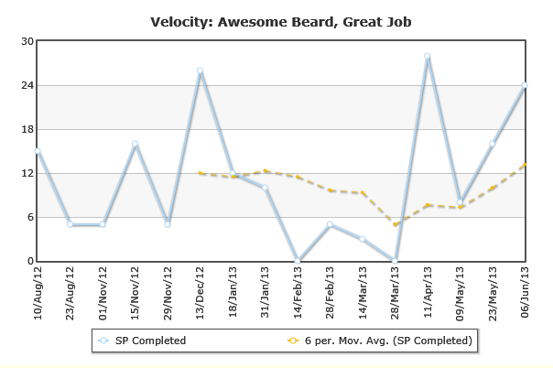

Normalized Velocity (0.40)
Given that velocity is actually used to help in project duration and the fact that this number cannot be compared to other teams; we have story points, per day, per person to help normalize fluctuations in team size / sprint duration. We don’t need to focus solely on the number, but on the trend. We want to constantly be getting better.

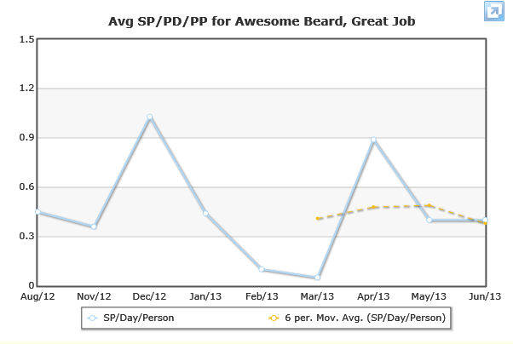

Sprint Review
Welcome to the Sprint Review. The purpose of this meeting is to demonstrate all the work items completed over the course of the Sprint. It is your time to offer feedback and comments related to any of the items presented. Thank you for your attendance and participation. Your help ensures that we are building the right system, the right way, and delivered at the right time.

Oprah Markham

120339: FAMIS Login (5 SP)
As an administrator, I need to be able to grant users access without them having to wait on an email so they can be setup if their email gets lost.

- Demonstrate that I can search for the users by user name
- Demonstrate that I can select them and choose to re-send the welcome email
- Demonstrate that I can bypass the welcome email and set them up
- Demonstrate that I can view the site as that user once they are setup
- Demonstrate that when I view the site, I don’t have to login as them

338393: Expose Create Account Resource (3 SP)
As an API consumer (developer), I need to be able to harness the “Create Account” resource in the API and pass credentials from NOMIS system so that all of the business logic can remain consistent in the FAMIS application.

Jeff Addison

*384737: COSMOS Brinker Report 955 (8 SP)
As a STARR Entry Field Person, I need to be able to automatic run the 955 Brinker Field Report upon access to the system so that all the data is ready to consume for the audit up on check-in.

- Demonstrate that upon login and check-in station selection, the 955 Brinker Report is available for immediate download
- Demonstrate that I don’t have to search for this report, it should present itself upon location selection
- Demonstrate that the Brinker Report is specific to the check-in station location
- Demonstrate that it is available to print in color

